


Internship Program Expressions of Interest form
Form version: March 2026
Title: <Insert here>
Date:

We acknowledge the traditional custodians across all the lands on which we live and work, and we pay our respects to Elders both past, present and emerging. We recognise that these lands and waters have always been places of teaching, research and learning.

Overview
Natural Hazards Research Australia (the Centre) is Australia’s research centre for natural hazard resilience and disaster risk reduction. The Centre works closely with the Australian Government and other stakeholders across Australia to deliver a strategic research agenda for the nation.
Natural hazards include bushfire, flood, cyclone, heatwave, storm, inundation and coastal erosion caused by sea level rise, earthquake, tsunami and landslide.
The Centre’s mission is to work with partners and the community on research that is useful, actionable and supportive of better decision making to save lives and protect communities. The Centre will generate and support research that is useful, usable and used by the sector and community.
The Centre’s research plan is outlined in a rolling Biennial Research Plan. These plans are reviewed annually to make sure the Centre is responding to new knowledge needs. Each Biennial Research Plan outlines the Centre’s key research focus areas. The current Biennial Research Plan covers the research for the second half of 2025 through 2027 and is available to download under ‘corporate resources’ on the Centre’s website.
The Centre will deliver the 2026/27 Internship Program in partnership with Australian Postgraduate Research Intern (APR.Intern) – the industry engagement arm of the Australian Mathematical and Sciences Institute. Up to four internships will be funded by the Centre in alignment with the Centre’s mission and objectives. The program strengthens collaboration between academia and end-users through integrated work placements, contributing to long-term skills and workforce development as outlined in the 10-Year Research Strategy (2022) and Biennial Research Plans.
This Expression of Interest (EOI) form is for Centre Participant organisations interested in hosting an intern as part of the 2026/27 Internship Program. Participants are required to outline a proposed project, explain how it aligns with the Centre’s mission and objectives, and demonstrate the benefits for both your organisation and the intern. By completing this EOI, Participants are requesting consideration for funding support for internships that will contribute to building skills, collaboration and workforce capability for safer, more resilient and sustainable communities

Internship Program Overview
- Purpose: To support internships that align with the Centre’s mission, vision and objectives by building opportunities that strengthen collaboration between academia and end-users by combining education with work placements – a long-term focus on skills and workforce development, as highlighted in our 10-Year Research Strategy 2022 and rolling Biennial Research Plans.
- Quantity: Up to four (4) internships for 202627
- Funding support: The Centre will fund each internship up to $29,800 ex GST, comprising $19,800 for the intern and $10,000 to APR.Intern for facilitation.

Internship objectives for Centre Participant organisations
- Capability development: Gain hands-on experience working alongside a higher degree researcher to enhance skills in addressing natural hazard-related challenges. Exposure to applying research methods and approaches to address real-world scenarios and business challenges for a period of six months.
- Collaboration: Strengthen connections with researchers and build longer-term partnerships.
- Knowledge sharing: Assist in the dissemination of research findings and innovative approaches to addressing natural hazards, resilience and disaster risk reduction.
- Contribution and impact: Contribute meaningful outputs and practical impact to address your organisation’s knowledge needs.

Key dates
Key dates for the current submission round are:
31 March 2026 Submissions open
15 May 2026, 5:00 pm AEST Submissions close
30 May 2026 Submitting organisations notified of outcome
The Centre reserves the right to make changes to these timeframes as processes evolve.

Who can submit?
EOIs must be submitted by representatives of one of the Centre’s Participants: organisations or entities that have signed a Participant Agreement with the Centre. See below for a list of Participant organisations.
Note: The Centre does not accept EOIs submitted by research organisations.

The following table lists the Centre’s current Participant organisations:
PARTICIPANTS
NATIONAL  - Australasian Fire and Emergency Service Authorities Council (including AIDR and NAFC)  - Australian Red Cross  - Energy Networks Australia  - Green Cross Australia  - Fire Protection Association Australia (FPA Australia)  - Gender and Disaster Australia | NSW  - NSW Reconstruction Authority  - NSW Rural Fire Service  - Fire and Rescue NSW  - NSW State Emergency Service  - NSW Department of Planning, Housing and Infrastructure  - NSW Department of Climate Change, Energy, Environment and Water  - NSW National Parks and Wildlife Service  - NSW Department of Customer Service
QLD  - Queensland Fire Department  - Healthy Land and Water | TAS  - Tasmania Fire Service  - Tasmania State Emergency Service  - Department of Natural Resources and Environment Tasmania  - Tasmania Parks and Wildlife Services  - Sustainable Timber Tasmania
SA  - SAFECOM  - Country Fire Service  - SA State Emergency Service  - Metropolitan Fire Service  - SA Department for Environment and Water | VIC  - Country Fire Authority  - Victoria State Emergency Service  - Department of Energy, Environment and Climate Action  - Emergency Management Victoria  - Fire Rescue Victoria
NT  - NT Government  - NT Fire and Rescue Service | ACT  - ACT Emergency Service Agency  - ACT Parks and Conservation
WA
- Department of Fire and Emergency Services
- Department of Biodiversity, Conservation and Attractions
- Landgate

Submissions
Submissions that fail to meet one or partially meet any of the mandatory criteria may be excluded from consideration by the Centre.
The Centre may in its absolute discretion seek further information or contact key stakeholders during the prioritisation process.

Mandatory criteria for submission
The mandatory criteria are:
1. | Applicants must be a Participant organisation of the Centre
2. | Applicants must identify an industry supervisor and provide information outlining a suitable hosting environment for an intern. Note: An industry supervisor is the professional at the host organisation who mentors, guides, and oversees an intern’s work and learning.
3. | Submissions must be made using the Centre’s March 2026 or later EOI form
4. | A Chief Executive, Commissioner or senior delegate of the submitting Participant organisation must endorse the EOI by signing this form.
Note: Participant organisations do not have to currently be involved in an active research project with the Centre to apply.

Submission process
The submission process is designed to prioritise high quality internship proposals that strategically align with the Centre's Biennial Research Plan 2025-27, while building opportunities that combine education with work placements – a long-term focus on skills and workforce development.

Applicants must submit a formal Expression of Interest using the Expression of Interest form.

Ideas for internships projects are initially submitted to the Centre via the form below. If an internship project has been prioritised for funding, the Centre will work collaboratively with the submitting stakeholders to develop a more detailed project plan.

All internship project EOIs must be submitted using the Centre’s March 2026 or later form via email to research@naturalhazards.com.au by the end date indicated under Key Dates section.
All mandatory criteria must be satisfied prior to submission.

For applicants who are unsuccessful, the Centre reserves the right to consider funding those EOIs if additional funding were to become available at a later date.

Submission process timeline
- Call for EOI submission open: 30 March for the 2026/2027 financial year
- Call for EOI submission deadline: 15 May
- Results notification: By 30 May
- Internship project plan development: One week after notification.
- Internship tripartite agreement (APR.Intern, host organisation and intern’s administering institution)
- Execution: After interns have been appointed

Prioritisation criteria
Submissions will be prioritised for inclusion in the Centre’s internship program based on the extent the expression of interest addresses the following research prioritisation criteria and their weight:
1. Strategic alignment and relevance (25%)
- Centre alignment: Proposed internship project directly aligns with natural hazard research focus and capability areas in the Biennial Research Plan 2025–27.
- Internship objective match: Clear contribution to capability development, collaboration, knowledge sharing and contribution/impact.
- Project quality: Internship projects are well structured and designed to provide practical learning opportunities and tangible outputs that will be useful, usable and used by the submitting Participants.

2. Collaboration and engagement (25%)
- Genuine partnership: Meaningful involvement of internal experts to guide, support and mentor the intern
- Network building potential: Capacity to create lasting professional relationships and opportunities for the intern to engage with diverse professionals.
- Knowledge and capacity building: Mechanisms to enhance the intern’s skills, expertise and professional development.

3. Feasibility, risk, and impact (25%)
- Risk assessment and management: Identification of potential challenges and mitigation strategies including contingency planning for managing operational, safety, and workplace risks and potential disruptions (e.g. illness, personnel changes, natural hazard events).
- Insurance: Appropriate insurance and compliance measures.
- Budget and resource realism: Sufficient resources, tools, and support provided to deliver a meaningful internship experience, noting the internship (if successful) will be funded to the amount of up to $29,800 ex GST, comprising $19,800 for the intern and $10,000 to AMSI (APR.Intern) for facilitation.
- Contribution and implementation pathways: Opportunities for the intern to contribute to projects and for outputs to have practical value.

4. Quality of hosting environment (25%)
- Relevant expertise and experience: Host organisation has appropriate skills, knowledge, and experience to support the intern and deliver meaningful learning outcomes.
- Stakeholder commitment: Level of confirmed participation, organisational support, and resources dedicated to mentoring the intern.

Contacting the Centre
For more information regarding submitting an Expression of Interest, please contact research@naturalhazards.com.au

Primary and supporting contact details
In the form below, you will need to provide details of a primary contact and any supporting contacts to assist the Centre in effectively communicating with people involved.
All supporting contacts will be advised of the submission outcome and may also be contacted during the Centre’s prioritisation process to seek clarifications or obtain further information.

Proposed internship project title: Click or tap here to enter text.
Host organisation (Participant) | Please provide name of host organisation  Organisation:
Primary contact person | Please provide details of the primary contact involved in developing this expression of interest  Name:  Phone:  Email:  Position within organisation:
Which of the following natural hazards does this project primarily address? (select all that apply) | ☐ Bushfire  ☐ Flood  ☐ Cyclone  ☐ Heatwave  ☐ Storm  ☐ Inundation and erosion caused by sea level rise | ☐ Earthquake  ☐ Tsunami  ☐ Landslide  ☐ All  ☐ Other  If other, please specify:  ____________________________

Internship alignment | Which of the following research themes, key focus areas and key capacity areas in the Centre’s current Biennial Research Plan does this concept most align with? (Select up to 2 for each category.) For a full description of the areas, please see the Centre’s current Biennial Research Plan.  Research themes (please prioritise top two in order, with 1 being highest priority)  ___ Communities and workforces of the future  ___ Evidence-informed policy, strategy and foresight  ___ Learning from disasters  ___ Operational response and innovation  ___ Resilient built environment  ___ Resilient communities  ___ Situational awareness  ___ Sustainable, safe and healthy landscapes
Internship alignment | Focus areas (please prioritise top two in order, with 1 being highest priority)  ___ Understanding and mitigating risk  ___ Land-use planning and urban design  ___ Resilient recovery  ___ Environmental solutions  ___ Next generation capability  ___ Social equity  ___ None of the above | Key capability areas (please prioritise top two in order, with 1 being highest priority)  ___ First Nations knowledges  ___ Data management and science  ___ Future workforce  ___ Community-led, place-based resilience  ___ Interoperability  ___ None of the above
Clearly explain how the proposed internship projectt aligns with the research themes, key focus areas and key capability areas identified. (Max 200 words)
<Insert text>
Provide a brief overview of the purpose and expected outcomes of this proposed internship. (Max 120 words)
<Insert text>
Describe the current need or gap the internship will address and explain how it aligns with internship program objectives such as capability development, collaboration, knowledge sharing, contribution and impact. (Max 150 words)
<Insert text>

Collaboration and engagement | Explain how the internship will contribute to the intern’s knowledge, skills, and professional growth, including practical learning opportunities. (Max 150 words)  <Insert text>  Describe the support and resources your organisation will provide to the intern, including staff mentorship, access to tools or facilities, and any specific training or professional development opportunities available during the internship. Examples include, but are not limited to; (Max 150 words)  - Building Professionalism (business writing skills, facilitating meetings & presentations, networking and etiquette etc.);  - Leadership & Management (managing stakeholder relationships, problem solving & judgement and project management & prioritisation etc.);  - Technical/Research in Business (real word application of research, specialist software skills and business environment software e.g. CRMs, Microsoft etc.);  - Organisational Knowledge and Core Compliance (Appropriate workplace behaviour, OH&S and managing information etc.)  - Exposure to key sector subject matter experts  <Insert text>  What other factors within the work environment will assist the Intern to develop their workplace skills and improve their work-readiness? (Max 100 words)  <Insert text>
Feasibility, risk, and impact | How will operational, workplace, and safety risks be managed during the internship, including insurance and compliance measures?  <Insert text>  How will the intern’s work contribute to practical outcomes and support your organisation’s objectives?  <Insert text>
Quality of hosting environment | Please provide details of the proposed industry supervisor. Note: the supervisor does not need to be research trained. The supervisor can also be the same as the primary contact person.  Name:  Phone:  Email:  Position within organisation:  <Insert additional secondary contacts>  Please provide an overview of the industry supervisor, including how background, experience, expertise and qualifications are suitable/aligned to the internship topic proposed. (Max 150 words)  <Insert text>  Please provide overview of the hosting environment, including the following: (Max 200 words)  - Organisational context, key responsibilities and core activities.  - Relevant expertise, skills and experience of your team (excluding proposed industry supervisor) that will support the intern.  <Insert text>
Internship design and delivery | Please describe the preferred skills, qualifications, and attributes of an ideal internship candidate. (Max 75 words)  <Insert text>  Internship location (select what applies):  ☐ In-person (specify city)  ☐ Virtual  ☐ Hybrid  Please specify the expected length (noting the Centre will prioritise internship projects that can be delivered within a six month timeframe. (Max 25 words)  <Insert text>  What is the industry context and the specific problem your organisation is facing? How would the proposed project help address it? (Max 100 words)  <Insert text>  Please indicate the skills or expertise the organisation is seeking and how a researcher could help address the problem. (Max 75 words)  <Insert text>  Please define 2–3 key objectives the internship aims to achieve. Focus on the main questions to be investigated. (Max 100 words)  <Insert text>  Please outline the resources required to conduct the project successfully and confirm if these are available. (Max 50 words)  <Insert text>  Please summarise the anticipated outcomes of the internship project. (Max 75 words)  <Insert text>  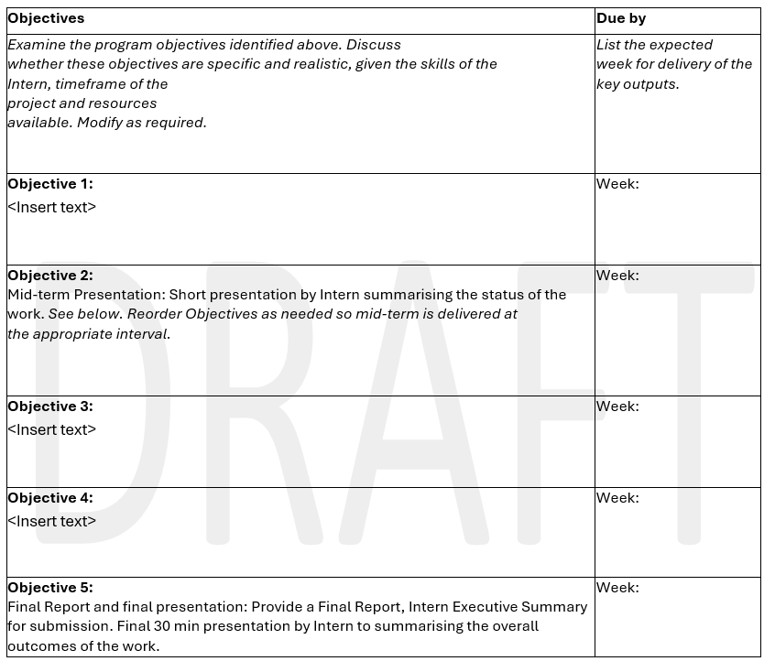  Sample Research Plan: Provide a rough outline of the research plan in the table below (to be finalised if the EOI is prioritised for funding). (Max 50 words)  As part of the internship, the Intern will complete the milestones listed below. These milestones are reflected into the research plan above. Please assign appropriate due dates.  - Halfway through the project, the Intern will give a short presentation to the summarising the status of the work.  - The intern will submit a Final Report, Intern Executive Summary.  - At the end of the internship, the Intern will give a 30-minute presentation summarising the overall outcomes of the work  Please outline any additional critical milestones or deliverables if relevant.  <Insert text>

Endorsement
A Chief Executive, Commissioner or senior delegate of the submitting Participant Organisation must endorse the Expression of Interest by signing this form.
Endorsed by:
_______________________________
Signature of Chief Executive, Commissioner or delegate
______________________________
Print Name of Chief Executive, Commissioner or delegate
Date:_________________

Checklist
☐ A primary contact has been nominated and the primary contact’s organisation is a Participant organisation of the Centre.
☐ The EOI form has been signed by a Chief Executive, Commissioner or senior delegate of the submitting Participant organisation.
☐ The primary contact acknowledges that the Centre may disclose information on this form to its advisors and subject matter experts.

